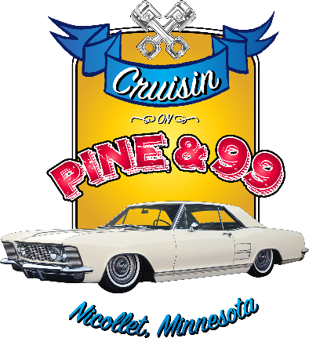
The 7th Annual Cruisin on Pine & 99 Nicollet Committee is seeking annual sponsors for the 2023 season. The 2023 event runs every-other Thursday starting May 11th through September 14th from 5 p.m. to 8 p.m. As we continue the tradition of this event our community will enjoy several evenings of area motorists and families coming to our community.
We strive to make our cruise-in one that car enthusiasts continue to frequent for years to come. The growth of this event will help continue to support Nicollet and our local businesses. If you know of anyone that would like to be part of the committee, we are always seeking additional committee members.
An annual sponsor can be individuals, groups, organizations or businesses who wishes to contribute a sponsorship for 2023. There are several sponsorships that we hope you will consider contributing to - a breakdown of the sponsorship options is attached to this letter.
If you wish to find out more about this event we will provide assistance at nicolletcruise@gmail.com or by contacting one of the committee members. Please feel free to contact us with any questions or concerns.
Sponsorship year is from May 1, 2023 to September 30, 2023
Sponsorship applications and check should be mailed to PO Box 321, Nicollet, MN 56074. Please use the enclosed self-addressed envelope. All sponsorship money is due back by March 1, 2023 to guarantee business information on the advertising materials. Make checks payable to Nicollet Chamber of Commerce.
We appreciate the generosity and support!
Lance Severin, Angie Lingl, Denny Hewitt, Brian Novak, Dave Krueger, Rick Hulke

2023 Sponsorship Plan Information
CONTACT NAME: _______________________________________________________________________
Sponsorship Name / Business / Organization: ________________________________________________
Address: ______________________________________________________________________________
Phone: ______________________________ Email: ____________________________________________
All Sponsorship Plans Include FREE T-SHIRT - SIZE: ______________________
PLATINUM Sponsor - $500
2 nights of a reserved table & highlighted parking spot for a vehicle and business materials
Sponsor plaque / year
Your Business announced throughout the night by DJ
Your business name and logo on the event T-shirt
(Please send your logo file in high resolution JPEG, PDF or TIFF format for best quality to nicolletcruise@gmail.com )
Your business name and logo on the advertising poster
GOLD Sponsor - $350
Sponsor plaque / year
Your Business announced throughout the night by DJ
Your business name and logo on the advertising poster
(Please send your logo file in high resolution JPEG, PDF or TIFF format for best quality to nicolletcruise@gmail.com )
SILVER Sponsor - $200
Your business name and logo on the advertising poster
(Please send your logo file in high resolution JPEG, PDF or TIFF format for best quality to nicolletcruise@gmail.com )
ALL Sponsorship money is due by March 1, 2023 to guarantee business information on the advertising materials.
Please make checks payable to Nicollet Chamber of Commerce
Any questions email nicolletcruise@gmail.com

