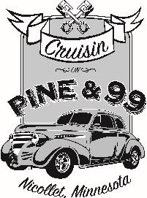
2020 SPONSORSHIP PLANS
Platinum Sponsor - $500
(10 major sponsors – Deadline is Feb. 1, 2020 or first come first serve, you can be a silent platinum sponsor priority given to pervious year sponsors)
2 nights of a reserved table and highlighted parking spot for car and business materials
Sponsor plaque
Your business announced throughout the night by DJ
Your business name and logo on the T-shirt
(Please send your logo file in a high resolution JPEG, PDF or TIFF Format for best quality)
Your business name, logo on the Chamber website and featured on event face book page.
Your business name and logo advertising.
One Free Tee Shirt ___XXL, ___XL, ___L, ___M
Gold Sponsor - $350
Sponsor plaque
Your business announced throughout the night by DJ
Your business name, logo on the Chamber website and event face book page
(Please send your logo file in a high resolution JPEG, PDF or TIFF Format for best quality)
Your business name and logo on poster.
One Free Tee Shirt ___XXL, ___XL, ___L, ___M
Silver Sponsor-$200
Your business name, logo on the Chamber website and event face book page
(Please send your logo file in a high resolution JPEG, PDF or TIFF Format for best quality)
Your business name and logo on poster.
One Free Tee Shirt ___XXL, ___XL, ___L, ___M

BUSINESS NAME: _______________________________________________________________
CONTACT Name: _________________________________________________________________
Phone Number: ________________________Email:________________________________________

All sponsorship money is due by March 1st, 2020 to guarantee business information on the advertising materials.
Please make checks payable to Nicollet Chamber of Commerce
Mail to PO BOX 321 Nicollet MN 56074
Any questions email: nicolletcruise@gmail.com

