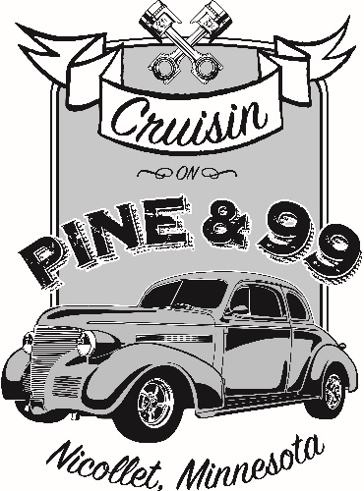

The 4th annual “Cruisin’ Pine & 99 Nicollet committee is seeking annual sponsors for 2020 to help support our upcoming Thursday night Classic Car Roll Ins. This year’s events will include 10 local Nicollet cruise-ins beginning on May 21st and running every other Thursday evening from 5:00 pm to 8:00 pm through Sept. 24th. In doing this, our community will enjoy several evenings of area motorists and families coming to our community, participating in our local business opportunities and acquaint themselves with Nicollet.
The club is being formed in dedication to car enthusiasts and to the preservation, use and enjoyment of historical, classic, muscle and special interest vehicles. Our hope is that the event will continue to grow so that we may support Nicollet and our local businesses.
An annual sponsor can be individual, group, organization or business who wishes to contribute a sponsorship for 2020. There are several sponsorships that we hope you will consider contribute to: A breakdown of these sponsorships are attached to this letter.
If you wish to find out more about this event we will provide assistance at nicolletcruise@gmail.com or by one of the committee members. Please feel free to contact us with any questions or concerns.
Sponsorship year is from May 1, 2020 to September 30, 2020.
Sponsorship application and checks should be mailed to PO Box 321 or contact a committee member to pick it up from you. All sponsorship money is due back by March 1st, 2020 to guarantee business information on the adverting materials.

We appreciate the generosity and support,
Alesia Slater, Rick Hulke, Lance Severin, Denny Hewitt, Tom Rieke, Brain Novak, Dave Krueger

2020 “Cruisin’ Pine & 99 Nicollet

Sponsorship Name / Business: _________________________________________________________________________

Address:____________________________________________________________________________________________

Phone / Email:_______________________________________________________________________________________
Sponsorship Applications and checks must be received by March 1st, 2020 to guarantee business information on the advertising materials.

